Benjamin Larose
IT 491
Week 3 Review Checklist

Do week 3 changes adhere to D3 naming, VLAN, addressing, interface and topology conventions? PASS
Do week 3 DNS records and NTP server/client configurations adhere to the approved design? PASS
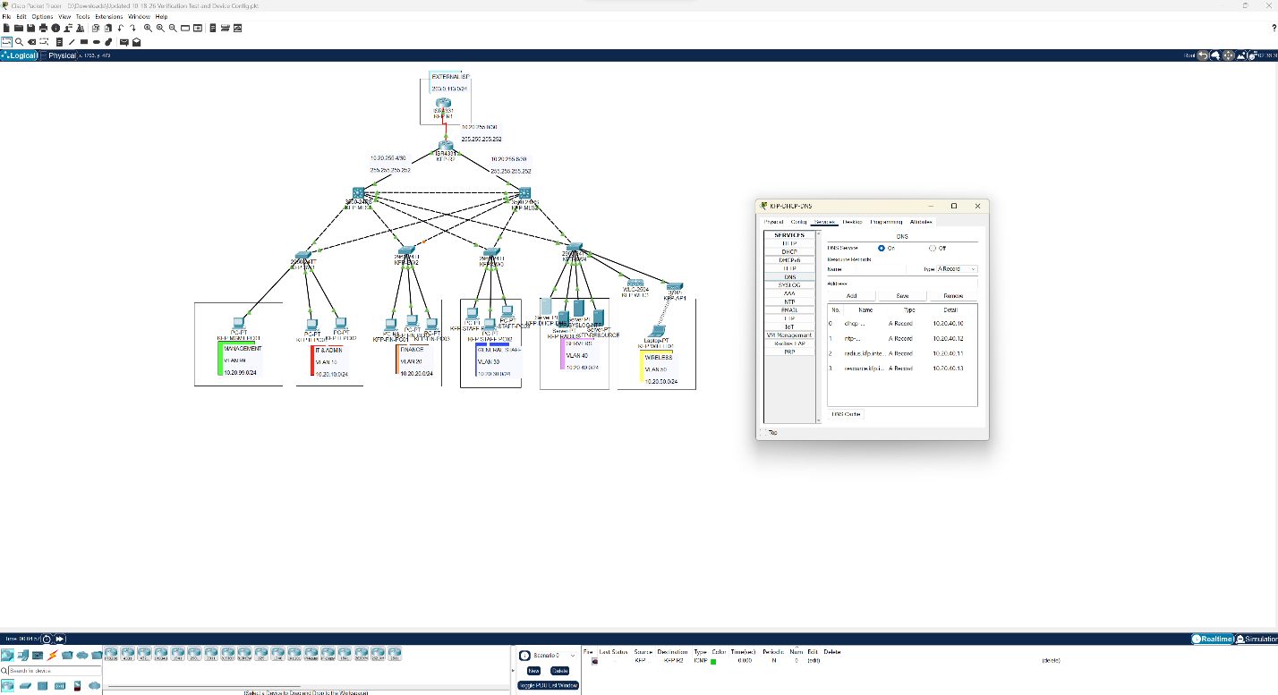

Do week 3 DHCP pools and MLS DHCP relay configuration adhere to approved VLANs/gateways/DNS plan? PASS
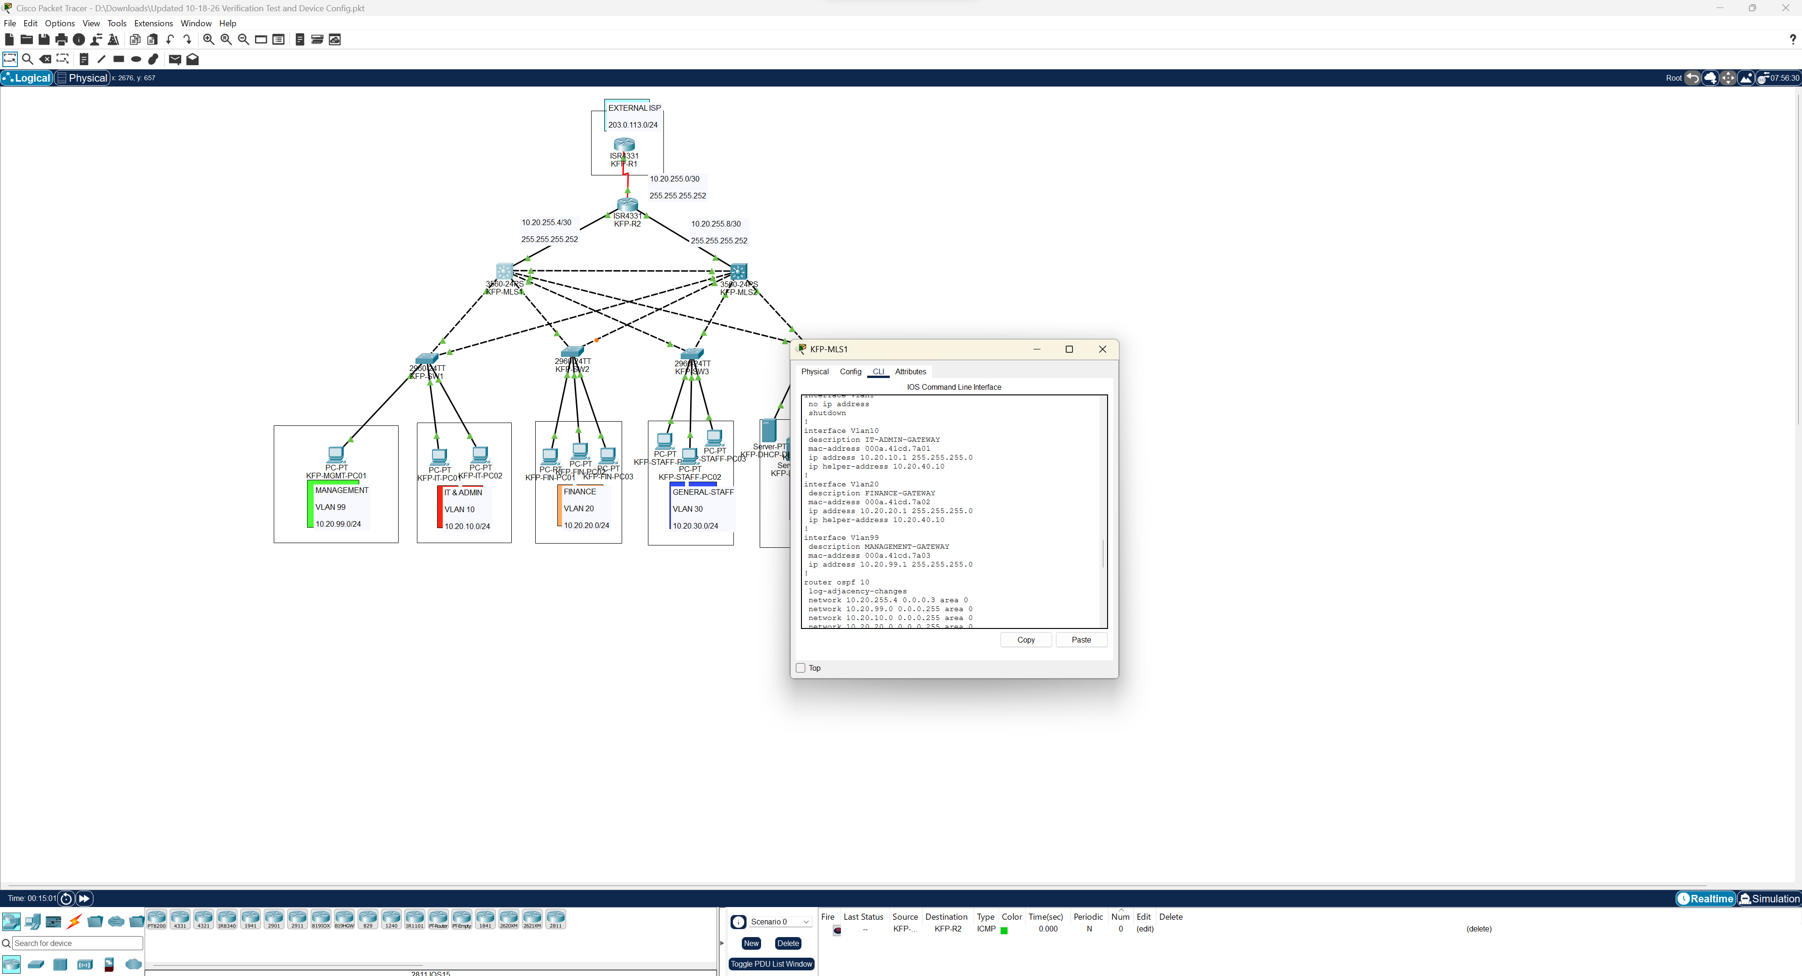

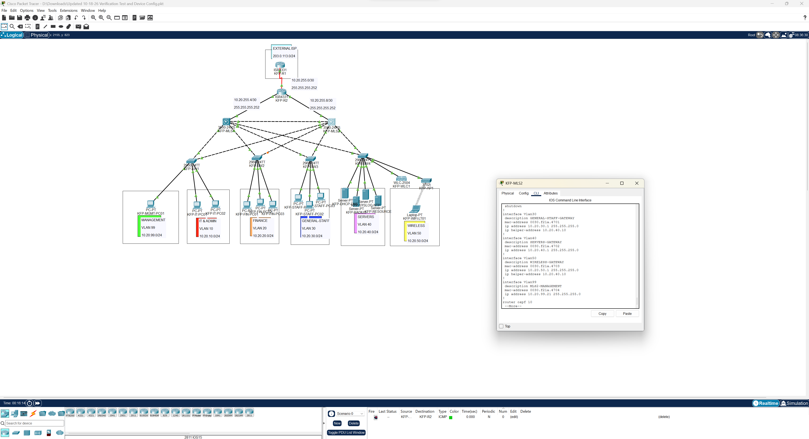

Review of SW2/SW3 trunk corrections and confirmation they did not introduce a configuration inconsistency? PASS

